Project Management 6
Assignment 6.1

1. How do you evaluate the performance of a project in agile?

Ans:
The performance of a project in agile can be measured using he following keys:
Key measures are:
- Velocity
- Hit Rate
- Work Remaining on Tasks
- Project Cost

Velocity
Velocity is a measure of the teams capacity to delivery in a Timebox. The unit of measure is the same as that used :
- For User Stories this is Story Points
- For Tasks this is actual hours.
The velocity predicted for first release plan created during Agile project i itiation is guessed or based from previous data after that the actual Velocity is measured at the end of each Timebox. This actual measure of Velocity is used to predict the Velocity for subsequent Timeboxes in the Release Plan. Agile processes promote a sustainable pace, so the Product Owner can’t cram more into a Timebox than the Velocity allows.

Hit Rate
The Hit Rate is the percentage of work allocated to a Timebox that was actually completed. Ideally a team should have a hit rate near 100%. A low Hit Rate indicates the team is struggling to meet their commitments

Work Remaining on a Task
Each day the team estimates the work remaining on each active Task. The estimate of work remaining Task will hopefully go down over time, but it may rise if the Task is more complicated than anticipates.
Three management measures are:

Cost performance index (CPI)

Cost Performance Index (CPI) = (Baseline Cost per Story Point) / (Actual Cost per Story Point)

CPI > 1 is an indication that cost incured for the project is less than what expected .
CPI<1 is an indication that the cost has exceeded the expected value.
CPI = EV/TAC
= (BC/SP)/(AC/SP)

Schedule performance index (SPI)

Schedule Performance Index (SPI) = (Actual Velocity/Baseline Velocity)

SPI > 1 is an indication that the project has finished earlier than expected.
SPI < 1 is an indication that the project has finished late than expedcted.
SPI = EV/PV
= AV/BV
Earned business value (EBV)

Earned value is defined as “the value of work completed”. It is the amount that we should have spent for thenumber of story points that has been done,based on the baseline

If project goes according to plan CPI and SPI would = 1 every Sprint

Based on the SPI and CPI values we can understand whether the project is going on time and on budget. Thus it helps determine the performance of a project. The CPI and SPI does not check for the business value. The business value measures the outcome and not the outputs. It checks whether the customer satisfaction is guaranteed.

2. Compare traditional monitoring & control with agile monitoring & control with respect to metrics generation

2. Answer:
Traditional monitoring and control | Agile monitoring and control
- The actual performance of a project cannot be estimated easily in the traditional method. | - Technical performance, schedule and actual cost can be estimated by comparing the earned value (EV) with the planned value (PV)
- Business value is not determined | - EBV is used to calculate business value
- Monitoring and control will only occur in last phase of the project. | - Each sprint release undergo monitoring and control in the agile method
- Effort is calculated only at the last phase of the project. | - Effort is calculated on each sprint.
- Quality is measured in only one phase in the whole project life. | - Quality is measured in each sprint life cylcle.
- Risk matric is calculated for finding the open,closed risks associated with the project for the whole life. | - Risk will be checked for each sprint release.
- Variance from the plan is considered bad unless it is approved by Change Management. | - Variation is not considered bad and changes plan to suit the current position.
- No burn down charts are created here. | - Results are demonstrated using the burn down chart.
- Delivery of software is only done after the final developement, hence customer is invloved only at the user acceptance testing. | - Highest priority is to satisfy the customer  through early and continuous delivery  of valuable software.

3. With a total project budget of $ 175,000, and having
completed one out of four Iterations, we have this product backlog and these actuals:

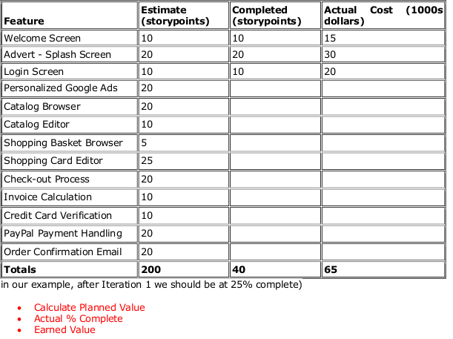
3. Answer:
Given :
Total project budget – 175000
Assume : 1 iteration complete 25%
Solution:

- Planned Value = Expected Percent Complete * Total Budget
=25% * 175,000
= 43,750

- Actual Percent = total number of storypoints completed / total number of storypoints estimated

= 40 / 200
= 20%

- Earned Value = Actual Percent Complete * the Total Budget
= 20% *175,000
= 35,000

